**End Course Summative Assignment-Product Dissection**

**Problem Statement**

**Product Dissection for top leading Platforms**

Welcome to this case study on dissecting and designing products for top leading platforms. In this case study, you will delve into the intriguing world of schema design for a prominent platform of your choice. Your task is to choose a top leading platform, research its features, and meticulously craft a schema design that encapsulates the essence of its functionality. By focusing on key entities, attributes, and relationships, you will gain invaluable insights into how data architecture drives the platform's effectiveness.

**Step 1: Choose a Leading Platform**

Select a leading platform of your choice, which could span various domains such as social media, e-commerce, finance, or any other industry. This choice will form the foundation of your exploration into its schema design.

**Step 2: Research:**

Thoroughly research the platform you have selected. Investigate its core features, functionalities, and user interactions. Identify the top features that define its user experience and contribute significantly to its popularity.

**Step 3: Product Dissection and Real-World Problems solved by the platform**

In this step, you will meticulously analyse the platform's standout features and how they provide innovative solutions to real-world challenges. By identifying key functionalities that resonate with users, you'll unravel how the platform effectively addresses problems and enhances user experiences. This dissection will serve as the foundation for understanding how the schema design aligns with the platform's core objectives.

**Step 4: Case Study on the Real-world problems and approach to solving them**

In this pivotal step, you will expand on the real-world challenges uncovered in Step 3 through a comprehensive case study. Delve into specific instances where users encountered difficulties and showcase how the platform's unique features provided effective solutions. By dissecting the approach taken by the platform to overcome these challenges, you'll gain a deeper appreciation for the platform's user-centric design philosophy and how it shapes the schema design.

**Step 5: Schema Design Based on Top Features**

Based on the features you have identified, craft a schema design that reflects the platform's data structure. Focus on the key entities, attributes, and relationships that underpin the chosen features. Your schema should capture the essence of how the platform organises and utilises its data.

**Step 6: Rationale Behind the Design**

While creating the schema design, consider the rationale behind the platform's choices. Reflect on why certain entities and relationships were chosen and how they align with the platform's goals. This will help you understand the strategic decisions driving the schema's architecture.

**Step 7: Create an ER Diagram**

Utilise tools like the Miro platform or similar applications to create an illustrative Entity-Relationship (ER) diagram. This diagram should vividly depict the entities, attributes, and relationships present within your schema design. The ER diagram will serve as a visual representation of your insights.

**Step 8: Presentation of Findings**

Present your findings in a clear and concise manner. Showcase your understanding of how the schema design impacts the platform's functionality and user experience. Explain how your chosen features are integrated into the schema and how the schema's structure supports the platform's objectives.

**Task Details:**

1. **Answer Submission:** Your submission should include well-structured solutions for all provided questions related to product schema designs.
2. **Video Creation:** Create an informative and engaging video where you thoroughly explain the Case Study.
3. **Depth and Clarity:** Ensure your solutions are detailed and showcase your understanding of product schema design principles. Similarly, in the video, provide clear explanations that are easy to understand for a wide audience.
4. **Creativity Encouraged:** You are welcome to utilise visuals, diagrams, or creative elements to enhance the clarity and impact of your explanations.

**Note:**

1. Duplicate this document and proceed to write your solutions and prepare your video.
2. Include the video link in this document before final submission.

Best of luck in completing this project and showcasing your prowess in dissecting and designing product schema for leading platforms! **For reference, we have also conducted a case study on Instagram, which you can find below. This case study will provide you with valuable insights into how schema design plays a pivotal role in shaping the functionality and success of a prominent platform.**

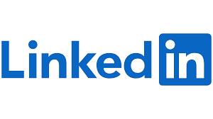

**Product Dissection for LinkedIn**

**Company Overview:**

LinkedIn began in co-founder [**Reid Hoffman's**](https://www.linkedin.com/in/reidhoffman/?src=or-search&veh=www.google.co.in) living room in 2002 and was officially launched on May 5, 2003.LinkedIn is the world's largest professional networking platform, connecting professionals from diverse industries, fostering meaningful connections, and facilitating career growth. It has Over 800 million users worldwide, and was acquired by Microsoft in 2016, LinkedIn is Industry-leading platform for job searching, networking, and professional development. LinkedIn empowers professionals to build and nurture their networks, share insights, and access opportunities that drive career success. Our platform serves as a global hub for networking, job searching, and professional growth, with a commitment to fostering a diverse and inclusive community.

**Product Dissection and Real-World Problem Solved by LinkedIn:**

LinkedIn's core feature is the creation of detailed professional profiles. These profiles serve as digital resumes for individuals, allowing them to showcase their skills, work history, education, and endorsements. This feature addresses the problem of traditional resume limitations and enables professionals to present a more comprehensive and dynamic representation of their qualifications.

LinkedIn offers a powerful networking platform where users can connect with colleagues, peers, mentors, and potential collaborators. This feature addresses the challenge of expanding one's professional network, which is essential for career growth, job opportunities, and knowledge sharing. LinkedIn has become a go-to platform for job seekers and recruiters. Job seekers can use the platform to search for job openings, receive personalized job recommendations, and apply directly through the platform. Employers and recruiters can find potential candidates with specific skills and experience, reducing the challenges of talent acquisition.

LinkedIn Learning provides a vast library of courses, tutorials, and learning materials on a wide range of topics. This feature addresses the need for continuous learning and skill development in a rapidly changing job market. Professionals can share articles, updates, and thought leadership content on LinkedIn. This fosters knowledge sharing, helps individuals establish themselves as industry experts, and provides valuable insights into current trends and topics.

Organizations can create and maintain Company Pages on LinkedIn, providing a platform to showcase their culture, products, and services. This helps businesses address the challenge of building a strong online presence and attracting talent and customers.

**Case Study: Real-World Problems and LinkedIn’s Innovative Solution**

One of the significant challenges many professionals face is finding the right job opportunities and advancing their careers. Job seekers often struggle to discover suitable positions, and recruiters face challenges in identifying qualified candidates. LinkedIn's approach to addressing job search challenges is rooted in its user-centric design philosophy. Here's how it accomplishes this:

Problem 1: Personalized Job Recommendation

**Real-World Challenge:** Difficulty in Finding Relevant Job Openings

**LinkedIn’s Solution:** LinkedIn's algorithm analyses users' profiles, skills, work history, and connections to recommend job openings that align with their qualifications and career goals. This personalized approach helps users discover relevant opportunities quickly.

Problem 2: Robust Job Posting Platform

**Real-World Challenge:** Complexity of the Job Application Process

**LinkedIn’s Solution:** LinkedIn provides a platform for companies to post job openings and manage applications efficiently. It simplifies the job application process by allowing users to apply directly through their LinkedIn profiles, saving time and effort.

Problem 3:Networking for Career Advancement

**Real-World Challenge:** Limited Professional Network

**LinkedIn’s Solution:** LinkedIn encourages users to build and leverage their professional network. Users can connect with colleagues, industry peers, and mentors, increasing their visibility and access to potential career opportunities.

Problem 4: Skill Development and Learning

**Real-World Challenge:** Keeping Skills Current

**LinkedIn’s Solution:** LinkedIn Learning offers a vast library of courses and educational content to help users acquire new skills and stay competitive in their fields. This addresses the challenge of keeping skills up-to-date for career growth.

Problem 5: Industry Insights and Content Sharing

**Real-World Challenge:** Staying Informed about Industry Trends

**LinkedIn’s Solution:** LinkedIn's news feed and content-sharing features allow professionals to share insights, industry news, and thought leadership content. This keeps users informed about the latest trends and developments in their respective fields.

Problem 6: Transparent Job Application Process

**Real-World Challenge:** Lack of Feedback in the Job Application Process

**LinkedIn’s Solution:** LinkedIn enables users to track the status of their job applications and provides tools for recruiters to communicate with applicants. This transparency ensures a smoother and more informative application process.

**Conclusion:** LinkedIn's user-centric design philosophy shines through in its approach to addressing real-world challenges related to job search and career development. By providing personalized job recommendations, facilitating networking, offering skill development resources, promoting industry insights, and enhancing the transparency of the job application process, LinkedIn empowers its users to overcome career-related hurdles. This case study illustrates how LinkedIn's user-centric approach drives its success as the premier platform for professional networking and career advancement.

**Top Features of LinkedIn:**

1. **User Profiles:** LinkedIn allows users to create professional profiles that showcase their work experience, education, skills, and endorsements. This serves as a digital resume.
2. **Connections:** Users can connect with other professionals, forming a network of contacts. These connections can be colleagues, classmates, or industry peers.
3. **News Feed:** Similar to other social networks, LinkedIn has a news feed where users can share updates, articles, and engage with content from their network.
4. **Job Search:** LinkedIn is a significant platform for job seekers and recruiters. Users can search for jobs, receive job recommendations, and apply for positions directly through the platform.
5. **LinkedIn Learning:** Offering a vast library of courses and educational content, LinkedIn Learning helps users enhance their professional skills and stay competitive in their fields.
6. **Messaging:** LinkedIn offers a messaging system for users to communicate with their connections, including features like InMail for reaching out to people outside their network.
7. **Groups:** Users can join professional groups related to their industry, interests, or affiliations to connect with like-minded individuals, share knowledge, and participate in discussions.

**Schema Description:**

The schema for LinkedIn involves multiple entities that represent different aspects of the platform. These entities include User, Profile, Education, Experience, Skills, Connection, Job Posting, LinkedIn learning course, News feed post, Messaging, LinkedIn groups. Each entity has specific attributes that describe its properties and relationships with other entities.

**User Entity:**

The user Profile entity contains information about each user:

* **UserID** (Primary Key) – The Unique identifier of each customer
* **Full Name** – Full Name of User
* **Location** – Where they living right now
* **Contact Info** (optional) – The info like mobile number, email

**Profile Entity:**

* **ProfileID**(Primary Key)
* **UserID** (Foreign key) –
* **Headline** (Professional Title) – Description of what they do
* **Summary/Bio** – Overview of professional life
* **Industry** – The type of industries they are working

**Education Entity:**

* **Education_id** (primary key)
* **UserId** (foreign key referencing Users)
* **School name**
* **Degree**
* **Field of study**
* **Start date**
* **End date**

**Experience Entity:**

* **UserId** (foreign key referencing Users)
* **Company name**
* **Title**
* **Location**
* **Start date**
* **End date**

**Skills Entity:**

* **UserId** (foreign key referencing Users)
* **Skill name**

**Connection Entity:**

The connection entity contains information between the LinkedIn users:

* **ConnectionID** (Primary Key) – The unique identifier for each connection relationship
* **UserID** (Foreign Key) – Refers to the user making the connection
* **ConnectedUserID** (Foreign Key) – Refers to the user being connected with
* **Connection Type** (Colleague, Classmate, Industry Peer, etc.)

**News Feed Post Entity:**

The News Feed Posts entity stores the content shared by users on their LinkedIn news feeds.

* **PostID** (Primary Key) – A unique identifier for each customer
* **UserID** (Foreign Key) – The user who created the post
* **Content** (Text, Links, Media)
* **Timestamp**

**Comments Entity:**

* **CommentId** (primary key)
* **PostId** (foreign key referencing Posts)
* **UserId** (foreign key referencing Users)
* **Content**
* **Comment Date**

**Likes Entity:**

* **LikeId** (primary key)
* **PostId** (foreign key referencing Posts)
* **UserId** (foreign key referencing Users)

**Job Listing Entity:**

The Job Listings entity contains information about job opportunities posted by companies on LinkedIn.

* **JobID** (Primary Key) – A unique identifier for each job
* **Job Title** – The specific designation of a post
* **Company Hiring** – The name of the organization Hiring
* **Location** – The location where the organization is hiring for
* **Job Description** – The tasks, duties, function and responsibilities of a position.
* **Application Link** – Link on which we can able to apply for job
* **Date Posted** – The date on which the job is posted

**LinkedIn Learning Courses Entity:**

The LinkedIn Learning Courses entity represents the various educational courses available on LinkedIn Learning.

* **CourseID** (Primary Key) – A unique identifier for each course
* **Course Title** – The name of the course
* **Instructor** – The name of the person who’s teaching the course
* **Course Description** – The key content, knowledge and skills to be learned
* **Duration** – The time period till which a specific course is teach.
* **Skill** Level – It is the term used to define the level of skill going to teach in this course
* **Ratings and Reviews** – Allow customers to share their experience with a product or service, and give it an overall star rating.

**Messages Entity:**

The Messages entity captures the conversations between users on the LinkedIn messaging platform

* **MessageID** (Primary Key) – A unique identifier for each message
* **SenderUserID** (Foreign Key) – A user who sends the message
* **RecipientUserID** (Foreign Key) – A user who receive the message
* **Message** Content – Information contains with the message
* **Timestamp** – current time of an event that a computer record

**LinkedIn Groups Entity:**

The LinkedIn Groups entity represents the professional groups and communities that users can join on LinkedIn.

* **GroupID** (Primary Key) – A unique identifier for each group
* **Group** **Name** – The name of the Group
* **Group** **Description** – Details For which the group is created
* **Group** **Type** (Industry, Interest, Affiliation)
* **Group** **OwnerUserID** (Foreign Key) – The user who created the group
* **Number** **of** **Members**

**Relationships are:**

* **One-to-one** relationship between Users and Profiles, where one user can have only one profile, but one profile can belong to only one user.
* **One-to-many**relationship between Users and Connections, where one user can have multiple connections, but one connection can belong to only one user.
* **One-to-many** relationship between Users and Education, where one user can have multiple education, but one education can belong to only one user.
* **One-to-many** relationship between Users and Experience, where one user can have multiple experiences, but one experience can belong to only one user.
* **One-to-many** relationship between Users and Skills, where one user can have multiple skills, but one skill can belong to only one user.
* **One-to-many** relationship between Users and Posts, where one user can have multiple posts, but one post can belong to only one user.
* **One-to-many** relationship between Posts and Comments, where one post can have multiple comments, but one comment can belong to only one post.
* **One-to-many**relationship between Posts and Likes, where one post can have multiple likes, but one like can belong to only one post.
* **One-to-many** relationship between Posts and Shares, where one post can have multiple shares, but one share can belong to only one post.
* **One-to-many** relationship between Users and Groups, where one user can have multiple groups, but one group can belong to only one user.
* **Many-to-many** relationship between Users and Group_members, where one user can join multiple groups and one group can have multiple members.
* Each user (UserID) can have multiple work experiences, education records, skills, connections, and posts.
* Each connection (ConnectionID) relates to two users (UserID and ConnectedUserID) and has a connection type.
* Each post (PostID) is authored by a user (UserID) and can have multiple likes and comments.
* Each job listing (JobID) has details such as the job title, company, location, and job description.
* Each LinkedIn Learning course (CourseID) includes information about the course title, instructor, and ratings.
* Each message (MessageID) involves two users (SenderUserID and RecipientUserID) and contains message content.

**Rationale Behind the Design:**

1. **User Profile:**

* Rationale: The user profile is at the core of LinkedIn's platform. It provides users with a digital identity where they can showcase their professional background, skills, and achievements. This aligns with LinkedIn's goal of helping professionals build their online presence and network effectively.

1. **Work Experience and Education:**

* Rationale: Including work experience and education entities allows users to comprehensively present their professional history and educational qualifications. It assists recruiters and connections in understanding a user's background and expertise, reinforcing LinkedIn's role as a professional networking and job search platform.

1. **Skills:**

* Rationale: Skills are a critical aspect of a professional's identity and qualifications. Allowing users to list and endorse skills fosters trust and recognition within the LinkedIn community. It helps users highlight their strengths and areas of expertise.

1. **Connections:**

* Rationale: LinkedIn is all about building and nurturing professional relationships. The connections entity enables users to create their professional networks, connect with peers, colleagues, and industry professionals, aligning with LinkedIn's primary mission of facilitating meaningful connections.

1. **News Feed Posts:**

* Rationale: The news feed is a dynamic space where users can share knowledge, updates, and insights with their network. It encourages user engagement and interaction, which is vital for fostering a vibrant and active LinkedIn community.

1. **Job Listings:**

* Rationale: Job listings are a key feature of LinkedIn, addressing the needs of both job seekers and recruiters. By including job listings, LinkedIn helps professionals find career opportunities and supports companies in their talent acquisition efforts, thereby fulfilling its role as a career development platform.

1. **LinkedIn Learning Courses:**

* Rationale: LinkedIn Learning offers a platform for users to upskill and stay competitive in their fields. Including course information in the schema supports LinkedIn's commitment to professional development and continuous learning.

1. **Messages:**

* Rationale: Messaging is essential for communication and collaboration between professionals on the platform. It facilitates networking, job inquiries, and business discussions, aligning with LinkedIn's mission of fostering meaningful connections and interactions.

1. **LinkedIn Groups:**

* Rationale: LinkedIn Groups provide users with niche communities where they can engage in discussions, share knowledge, and connect with like-minded professionals. This feature supports LinkedIn's goal of creating a diverse and engaged professional ecosystem.

**ER Diagram:**

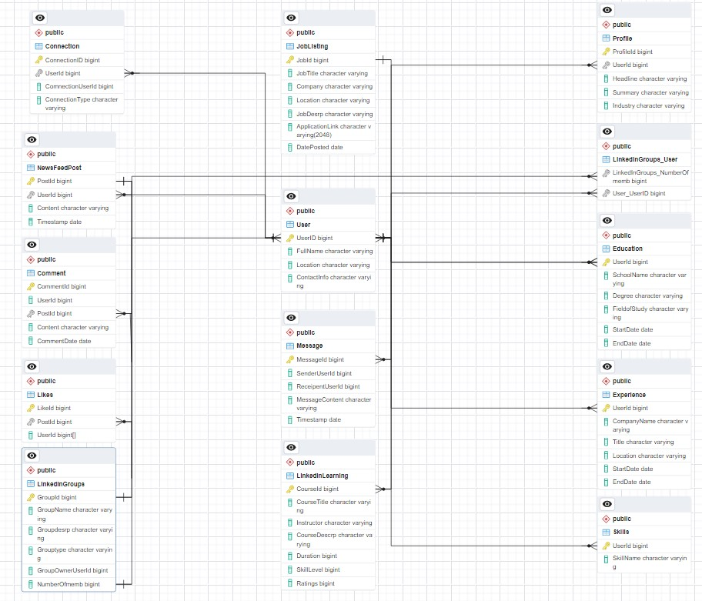

**Conclusion:**

LinkedIn's schema design is strategically crafted to align with its mission of connecting professionals, facilitating career growth, and providing a platform for knowledge-sharing and skill development. The chosen entities and relationships serve as the building blocks for achieving these goals, creating a user-centric environment that empowers individuals in their professional journeys.

Video Link:- <video1533291016.mp4>